**EDA Report for Project on Bitcoin Prize Forecasting**

**Introduction**

The dataset we are working is specifically introducing bitcoin exchanges for a period of 4 years 1 month from **November 30, 2014**, to **January 7, 2019**. Bitcoin is basically the long-standing cryptocurrency, first released in the year of 2009 as an open source by an unidentified ID ‘*Santoshi Nakamoto’*. It is working without any trusted record keeping authority. It is serving as decentralized platform of digital exchange with transaction authenticated and recorded in a public accessed ledger called **blockchain**. The new transaction blocks are interlinked with previous transaction blocks associated with a cryptographic hash called SHA-256. Hence, these are chained together and serve as an **immutable** document of all transactions occurred since the beginning.

The trend followed by bitcoin process highly depend on each time step. The values of new block (or time steps) depend upon the values of previous blocks (or time step). This dataset has timestamp of **Unix interval** format for selection of bitcoin trading exchanges. Unix has counts that starts at the Unix Epoch on January 1, 1970, and the Unix timestamp is merely the number of seconds between a specific time and the Unix Epoch. It is basically a method to study time as running total of seconds. The preprocessing in analysis will present the timestamp in datetime format with a **step of 1 minute**.

The bitcoin dataset exchanges minute to minute and gives updates of **OHLC** (Open, High, Low, Close), **Volume in BTC** (bitcoin) and indicated **currency**, and **weighted bitcoin price**. The different exchange APIs make it too challenging or confusing to obtain OHLC and volume data at 1-min intervals while collecting the dataset. The following file will represent basic exploratory data analysis and extract the trends of dataset.

**Classification of variables**

There are seven variables present in the dataset which are varying with our timestamp. A basic outlook of these variables is given below:

|  |  |  |
| --- | --- | --- |
| Title | Description | Datatype |
| Open | Numerical (Continuous) | Float |
| High | Numerical (Continuous) | Float |
| Low | Numerical (Continuous) | Float |
| Close | Numerical (Continuous) | Float |
| Volume (BTC) | Numerical (Continuous) | Float |
| Volume (Currency) | Numerical (Continuous) | Float |
| Weighted Price | Numerical (Continuous) | Float |
| Time Interval (Index) | Interval | Datetime Format |

The dataset is consisting of **2016354** observations and the details of variables are given below:

* **Open:** This parameter is defining open price of bitcoin when the trading period begins for trading session.
* **Close:** This parameter is defining close price of bitcoin when the trading period concludes for trading session.
* **High:** High is representing highest price of bitcoin achieved in that given time.
* **Low:** Low is representing lowest price of bitcoin achieved in that given time.
* **Volume (BTC):**  Volume BTC is describing the volume of bitcoins. It is usually the counts of bitcoins that are being bought and sold on specific exchange.
* **Volume (Currency):** It is describing the volume of currency being transacted in the specific window.
* **Weighted Price:** Weighted price is basically calculated from open, close, high and low parameters. This is price transforming tools used in this dataset. We can refer this variable as our target variable.
* **Time Interval:** This is index of bitcoin dataset, and it is formatted in datetime format per minute. This variable is our main explanatory variable.

**Exploratory Data Analysis**

The information of dataset is given below:

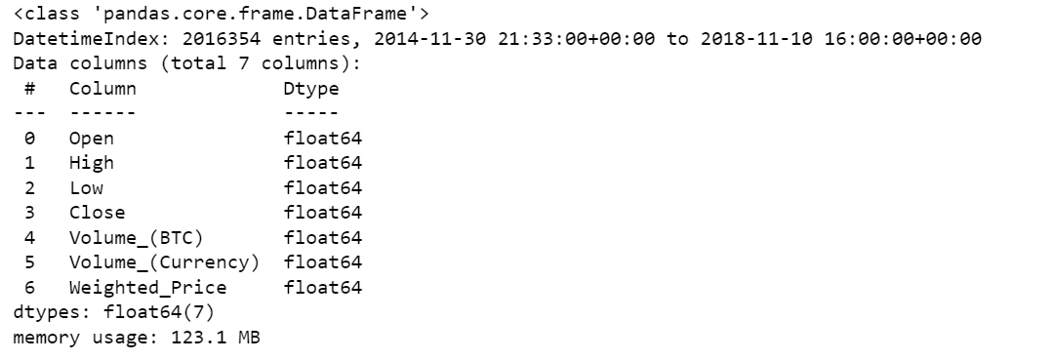

The above picture verifies the number of entries, parameters, and their data types with memory usage. A first glimpse of dataset is shown below:

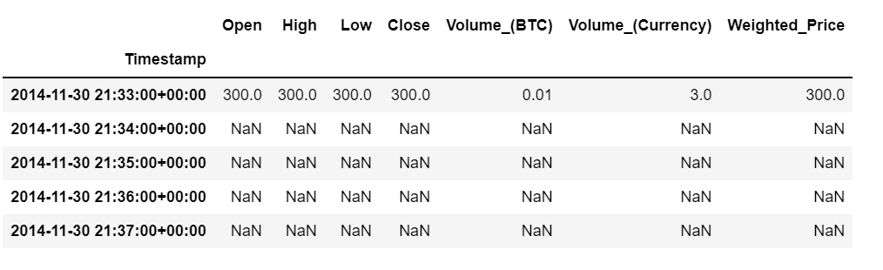

Since time series involves time steps as index, hence the starting and ending index are represented here:

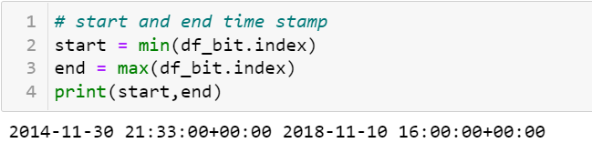

**Missing Values**

The dataset is having observations around 2 million. Thus, the chances of having missing values are significant. The following table below is describing the number of missing values each variable has. The missing values are consistent throughout the dataset and it can be concluded that the dataset may have missing rows.

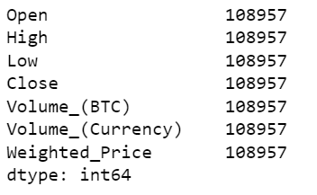

After **fixing missing values,** the dataset will take following shape. The criteria used for fixing of Open, High, Low, Close and Weighted_Price parameter is backward filling. These are the price values changing per minute and using bfill may not alter the trend of variables. Also a **naïve model** in time series states that its current value is highly dependent on its previous value.

Additionally, the Volume_(BTC) and Volumne_(Currency) parameter are replaced with a value zero and we have not used backward filling method in these. This is because these two variables are **single events** and cannot be aggregated, so assuming the sale volumes is not a correct measures.

Therefore, after fixing the missing values from the above said columns using appropriate backward filling technique, below can be seen as the proof that the missing values from the specified columns has be corrected. Hence, there are no missing values left in the data which can be seen in the screenshot below,

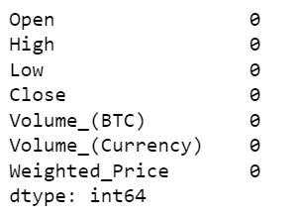

Below is the screenshot of the data after the missing values have been handled using bfill and replacing with zero as per the above specified explaination.

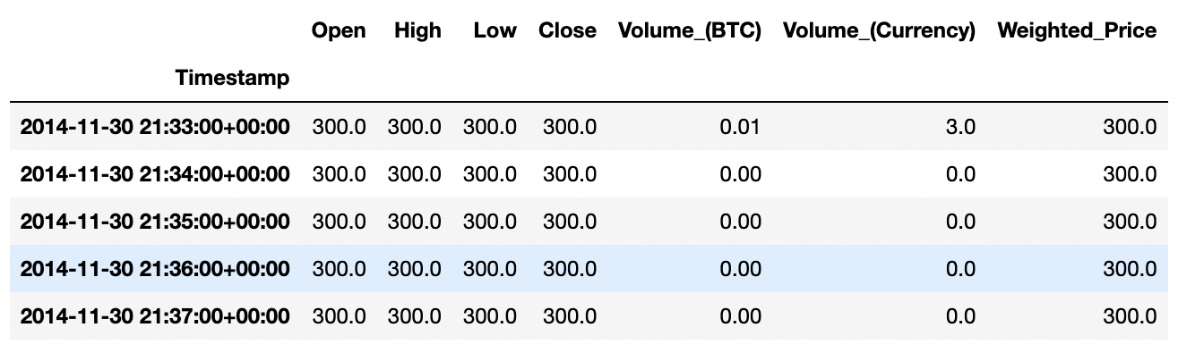

**Preprocessing – Changing Frequency to Weekly**

In the next step, the data is then changed from an hourly basis for each day to a weekly basis, precisely using the first timestamp as each Monday. In order to observe the weekly pattern of the transactions on the first day of the week, we are doing this by taking each week's Monday data and taking the initial timestamp into account. The following table is the end of the dataset view.

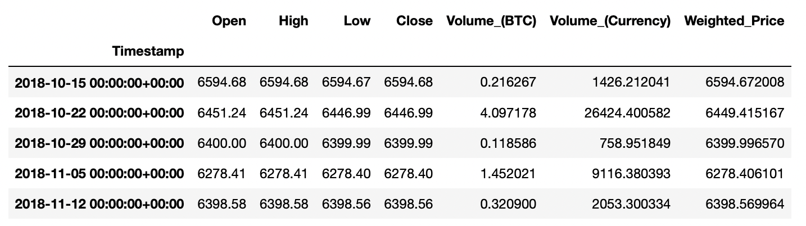

After changing the data to the weekly basis, next we are checking the correlation among all the variables, for which the correlation matrix is shown below,

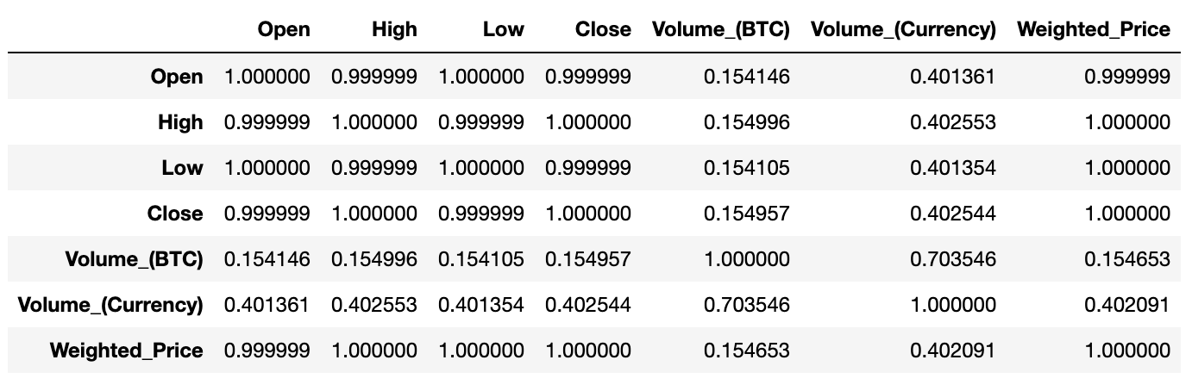

As seen from the correlation matrix, we can clearly see that there is a strong correlation between Open, High, Low, and Close with the correlation value of **0.999999 - 1** which can be considered to approximately **100% correlation**. Not only this, these variables are having a strong correlation with Weighted_Price parameter also with a value of **0.999999 - 1**. This is due to the fact that the Weighted_Price variable is derived from the other specified variables. Furthermore, the correlation among Volume_(BTC) and Volume_(Currency) is also significant with 0.703646 as both are realated to transactions of Bitcoin. Also, the correlation between Volume_(Currency) and Weighted_Price has also some weightage with 0.402091 as the transaction volume has a relation with the aggregate price.

**Visualization**

**Open, Close, Low, High and Weighted_Price**

After the fundamental preprocessing, we tried plotting the line graph for Open, High, Low and Close along with Weighted Price. As all these are variables are having a strong relation among each other and not only this, but the Weighted Price variable is also derived from the other four mentioned variables.

The visualization is created for all the data from the year **2014-12-30** to **2018-11-12** showing the trend of the Bitcoin price for each first timestamp of every Monday in the given period.

Moreover, the plot is created interactive which gives us the advantage to view the trend for each of the variable in the 1 Month, 6 Month, 1 Year and 3 Year span giving a better understanding of the prices for Bitcoin. The same can be seen below:

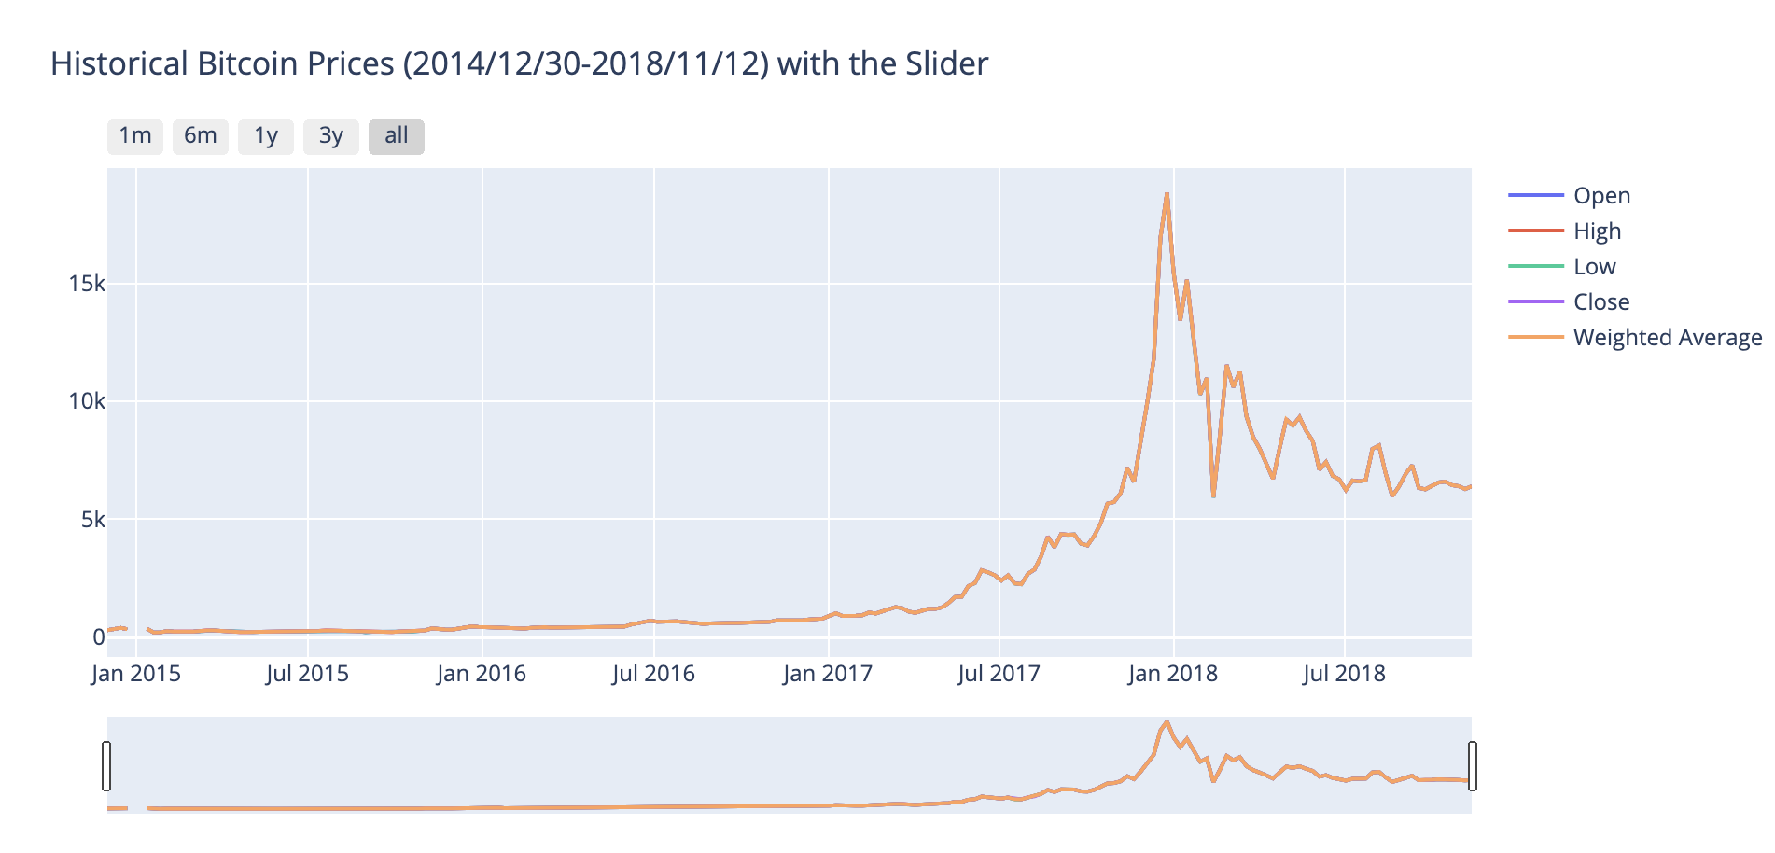

From the above graph, it is seen that these is a visibly increasing trend starting from the year **2017** and the peak is touched in **December 2017**. After that also there are a lot of ups and downs. Not only this, but we also analyzed that the trend for all the variables is significantly similar which we also saw in the correlation matrix before.

**Volume_(BTC), Volume_(Currency) and Weighted Price**

Next, we tried to plot the line graph for the Volume variables in comparison to the Weighted Price which gives us the idea about amount of Bitcoin exchange in a particular transaction and the volume of currency that the Bitcoin hold. As we are aware of that the Bitcoin is traded in US Dollar so all the currency volume can be considered as USD.

As the previous graph, this one is also an interactive plot showing the lines for the three variables for different time span from the year **2014-12-30** to **2018-11-12**.

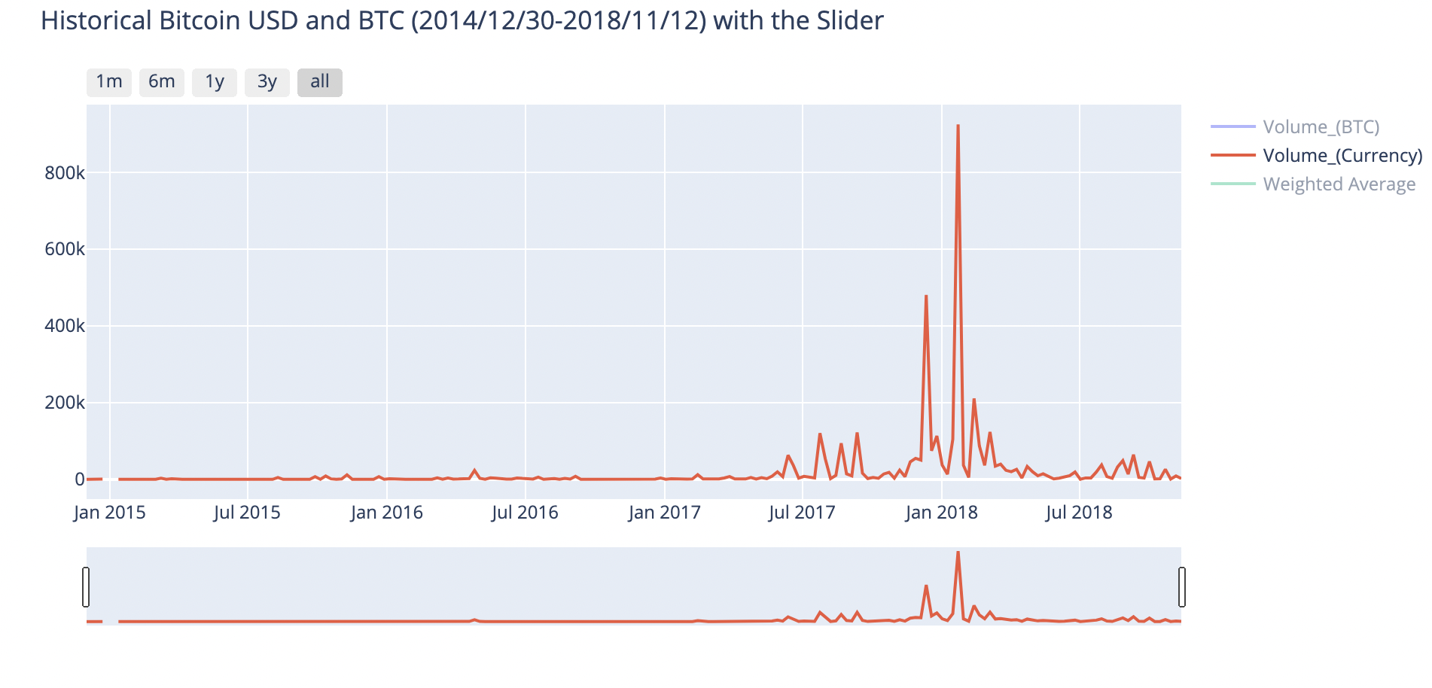

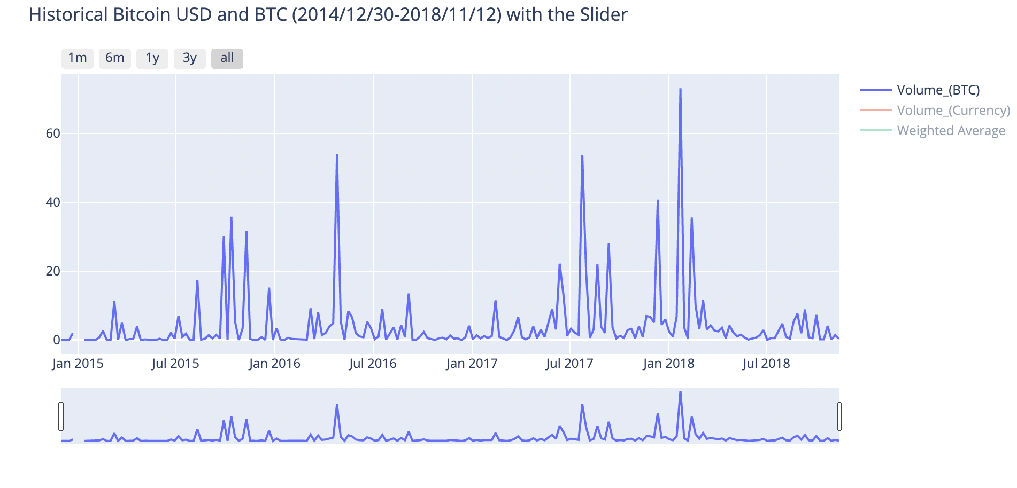

From the above plot, it is evident that there is high trend **last months of 2017** as seen in the last plot as well. Moreover, a huge spike in **February 2018** taking the amount above **800K** along with a similar trend in the Weighted Average variable.

**Weighted Price and Volume (Currency)**

Further, we created a regression plot among the two variables to understand the relation between them. It helps to be aware of the close relation of the datapoints between the variables.

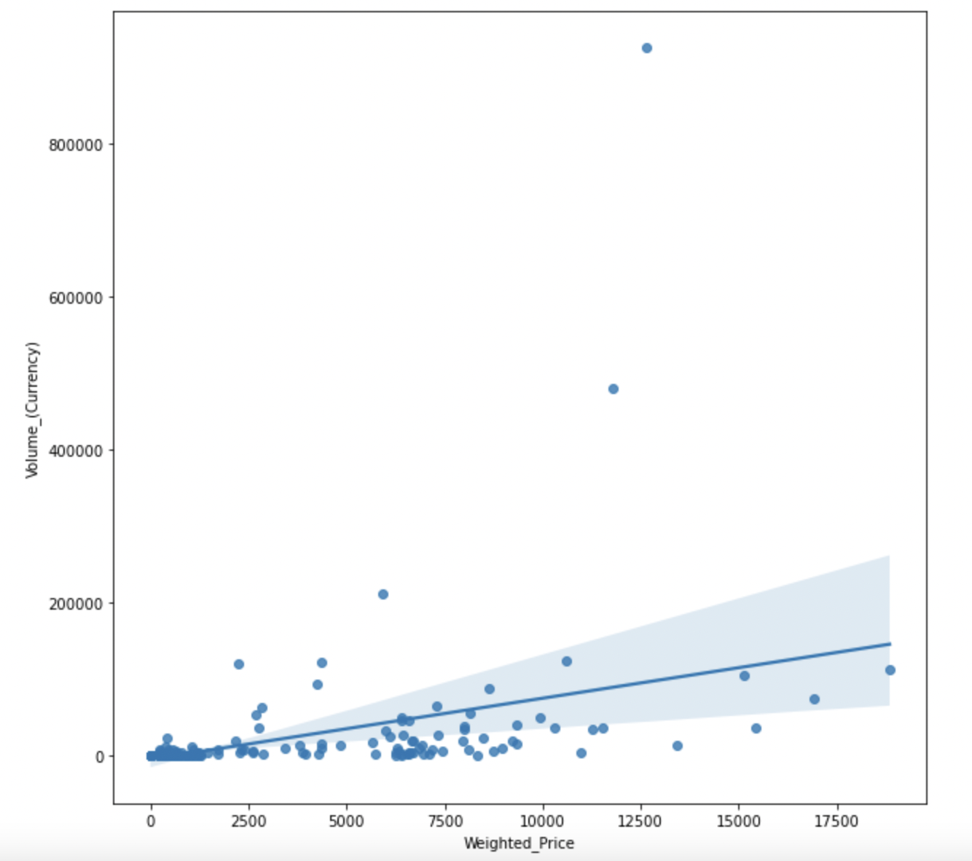

It is seen from the regression plot that the datapoints are very closely related with each other in the starting corner of the plot. Moving ahead it can be seen the datapoints are getting scattered and some outliers can also be seen. The similar relation was seen in the correlation matrix formed in the previous part of the report justifying the output of the regression plot.

**Data Preparation for Model**

Moving forward, we will now prepare the data for inputting in the model. We will be resampling the data into **Daily** and **Hourly** format for the seasonal decomposition and further analysis.

For this, we are taking in consideration the weighted price and replacing the zero value with null values that can also be said as missing values and further taking the null values and exchanging with the last values of the rows using backward fill. Not only this, for the volume variables we have replaced the null values with zero. The same approach is used for both the hourly and daily resampling.

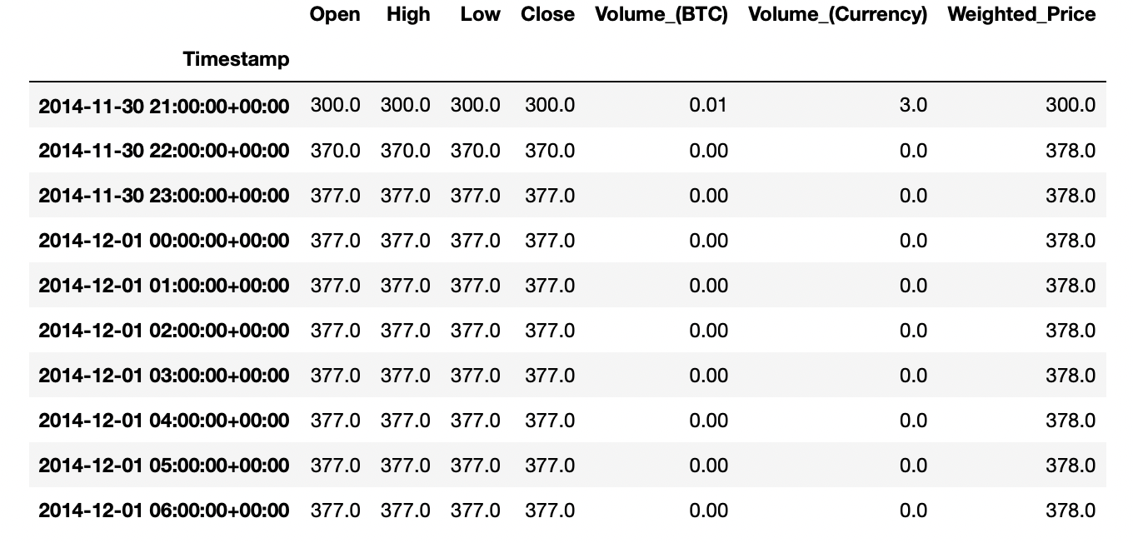

Hourly Resampled

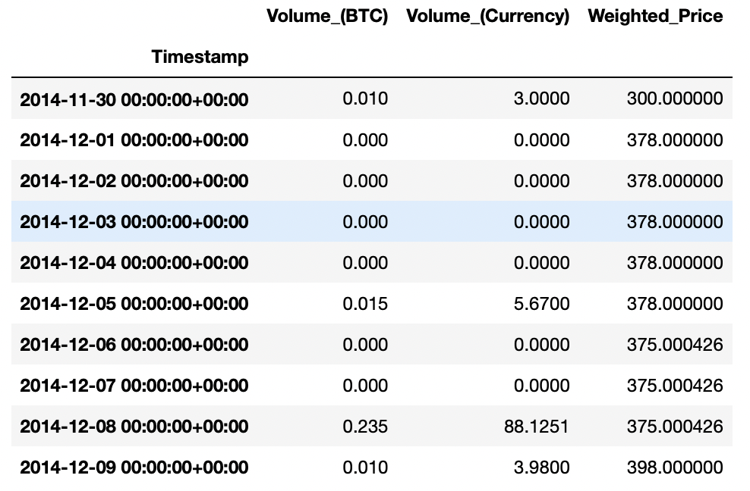

Daily Resampled

The resampling performed by replacing the values for the above said variables can be seen in the above show tables.

**Data Split: Train and Test**

As the next step, we will be splitting the data into two parts for training the model and testing the model. For the time series problem, we don’t follow the traditional approach of splitting the data into a specific ratio like 80:20 or 70:30.

For time series problem we use most of the data (historical) for training our model and recent data for testing. Following the same approach, we have kept a bigger chunk of data for training and rest for testing.

For training, we have taken in consideration roughly **3.5 years** of the data before **June 2018** out of the total of approximated 4 years of data. On the other hand, for testing we are taking the leftover data of **6 months after June 2018**.

**Seasonal Decompose**

In this part we will see the seasonal pattern of the data. For deriving the pattern, we are taking the data from January 1, 2015 to December 31, 2015 which is a full year of data. This will give us a clear idea about how Bitcoin performs over the different time of the year.

As weighted price is our target variable, this will help to see the fluctuations of the price based on the trend and seasonal pattern over the years’ time. For generating the patterns, we must check whether the data is stationary or not and we have used the test called **Dickey Fuller test**. This test is present in “statstools.adfuller” package

Here, the null hypothesis states that our data is **not stationary** if **p-value>0.05** and it will be **stationary when p>0.05 (for alternate hypothesis)**.From the following picture, the specified p-value is 0.48 which is greater than 0.05. Therefore, we fail to reject null hypothesis and our data is not stationary.

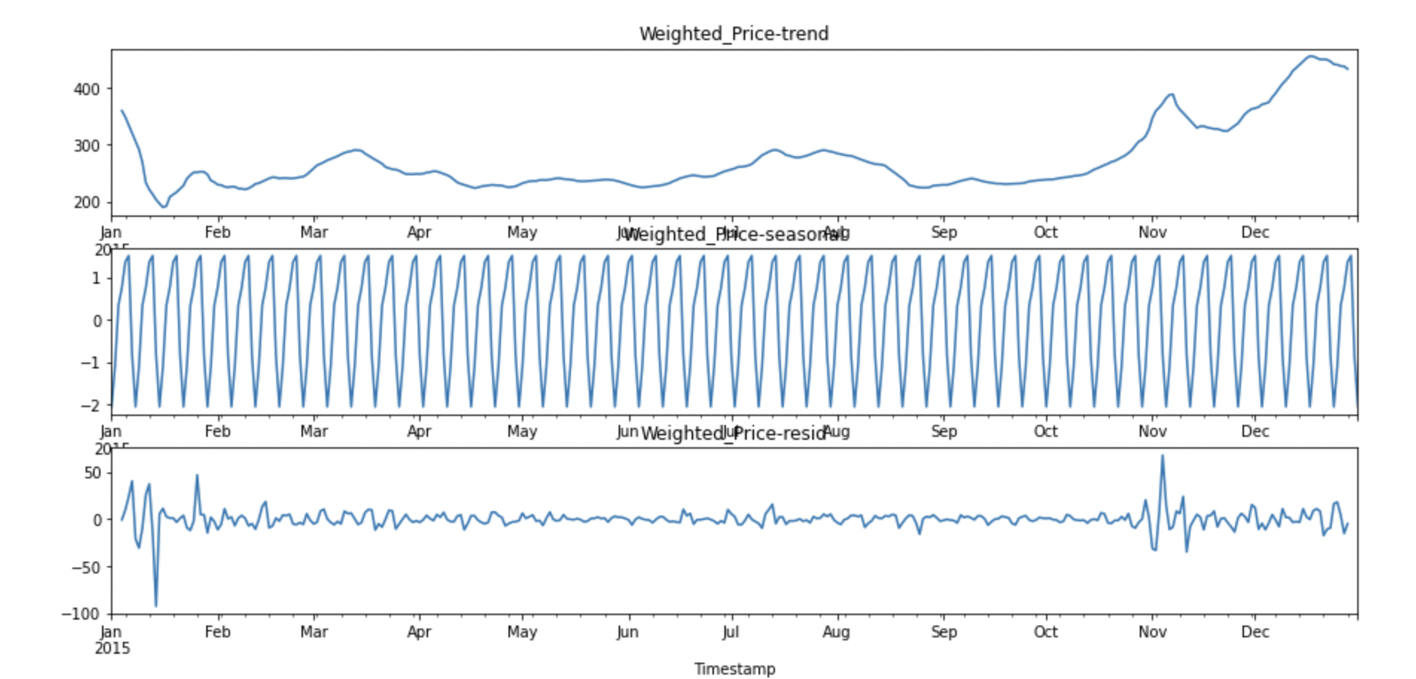

The first graph is representing the trend with highs and lows based on the different times of the year (Jan 1, 2015 to Dec 31, 2015). Second plot is verifying seasonal pattern as there is a similar pattern or seasonal pattern in each moth for the whole year with four spikes representing each week of the month. Thus, we can say that the **variable (weighted price) is having weekly seasonality**.

The last graph is representing the plot of residuals. Since maximum residuals pattern is centred around 0, thus this is having regular normal trend but some spikes in January and November clarify the nonstationary trend.

**Baseline model fitting for extensive EDA**

For the model fitting, we are using the “**Auto-Arima**” which is an automated arima modelling algorithm that seeks the best parameters for creating either **ARIMA (Auto Regressive Integrated Moving Average)** or **SARIMA (Seasonal Auto Regressive Integrated Moving Average)** model for forecasting. This also support **exogenous** variables while modelling SARIMAX, enabling us to work with multi-variant time series. Exogenous variables are the supporting explanatory variables in time series regression apart from time index variable.

We are considering **SARIMA** model here. Let’s understand in brief about the two important time series model:

**ARIMA:**

**AR (*Autoregression):*** As explained above, the model takes in account the dependency between an observation and a certain number of lag observations.

**I *(Integrated):*** The process of differencing raw observations to render a time series stationary, for as by removing an observation from an observation made at previous step. It is very essential as most of our time series model work on stationary data.

**MA *(Moving Averages):*** This is applied to lag-timed data that makes advantage of relationship between an observation and a residual error.

The parameters of ARIMA models are given below:

**p:** It is lag order generally defines the number of observations included in model

**d:** It is degree of differencing which usually account counts where raw observations are differenced. It is taking difference of lag and make it somehow stationary.

**q:** It is order of moving average or generally the size of moving average window.

Basically, a linear regression model is developed with the given number and type of variables, and the data is prepared by a degree of differencing to make it stationary, i.e., to remove trend and seasonal structures that adversely affect the regression model.

This process helps to highlight the necessities of model assumptions in raw observations and in residual errors of forecast.

**SARIMA is different from ARIMA as it considers seasonality as introduce P, D and Q with step size of seasonal pattern. These variables are defined as:**

**P:** This is seasonal autoregressive order or seasonal lag order which defines the number of observations included in model.

**D:** This is seasonal difference order and it calculate the difference of lag to control non stationary trend of variable.

**Q:** This is seasonal moving average order.

**m:** This is extra variable introduced in SARIMA as it describes the seasonality in variable. Therefore, it requires the step size with varying seasonality. ‘m’ is number of time steps for single seasonal patten. In this case **m = 7** (for weekly seasonal pattern).

Usually for the SARIMA model we need to provide p, d and q and P, D, Q and m values which are essential and calculated using statistical methods. We used Auto-ARIMA which performs all the test on our model and compare relevant results to choose best test depending upon the statistics. It can give us ARIMA or SARIMA results depending upon the decided metrics.

Following this, the Auto-ARIMA automatically provides the p, d and q values and P, D, Q and m which are suitable for the data to get an enhanced forecasting. For selecting the best model and hyper tuning, we used the AIC metrics. Auto-ARIMA tried all the combinations of parameter and returned the model (best) based on **lowest AIC score**.

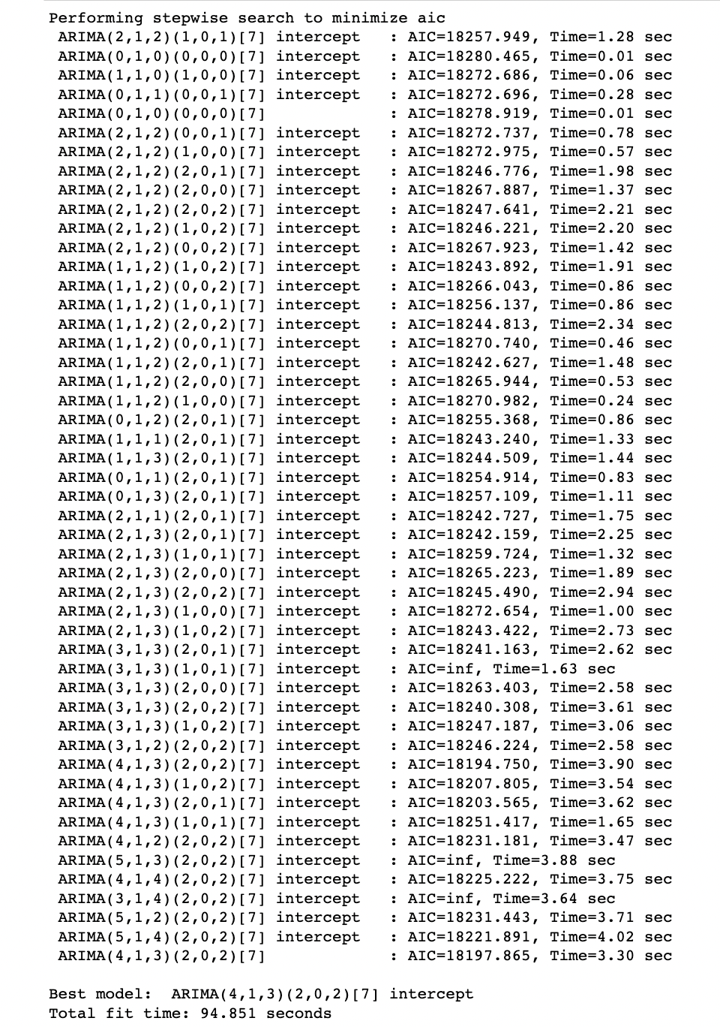

Since the variables of SARIMA are (4,1,3) (2,0,2) [7] which has similar consideration like SARIMA (p, d, q) (P, D, Q) m. Hence best fit model is SARIMA, and the statistics or summary of model is given below:

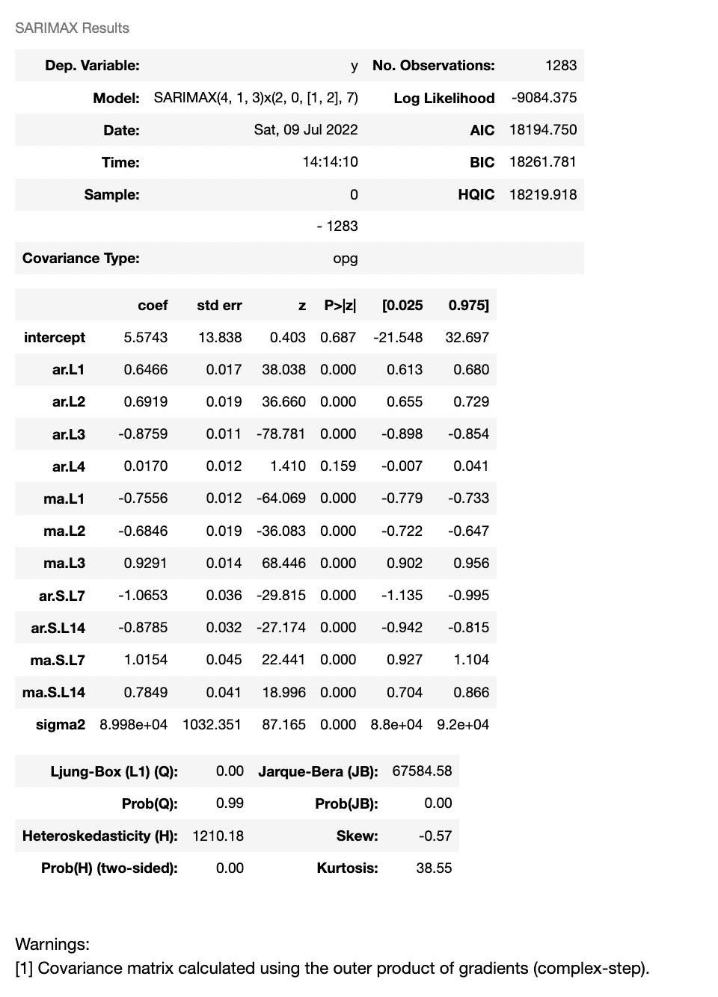

The model here described as SARIMAX (4, 1, 3)x(2, 0, 2,7) with all specified values and step size of 7. The AIC is lowest from where it started as shown in above picture. Therefore, this model is best fit model.

The next table defines the model lag variables and their statistics. The p-value for all variables is 0 which is less than 0.05 and we can reject null hypothesis. Also, the coefficients are significant with p-values (except intercept and ar.L4, this will be ignored while creating a SARIMA model separately). Thus, overall, the model is significant.

The JB probability value is 0 as well which is another parameter that validates the significance of model. The parameter Skew = -0.5 this shows the variability of homoskedasticity of residuals which are thus not normally distributed.

**Residual Analysis**

As we start from standard residuals, it is quite similar to the plot of residual in seasonal decompose. Maximum residuals are centralised around 0 but in the far domain, the residue is following variable trend. The histogram density plot and QQ plot present the skewness of residuals which is skewed on both sides of 0. Thus, this confirms the nonstationary trend of the variable, weighted price and skewness.

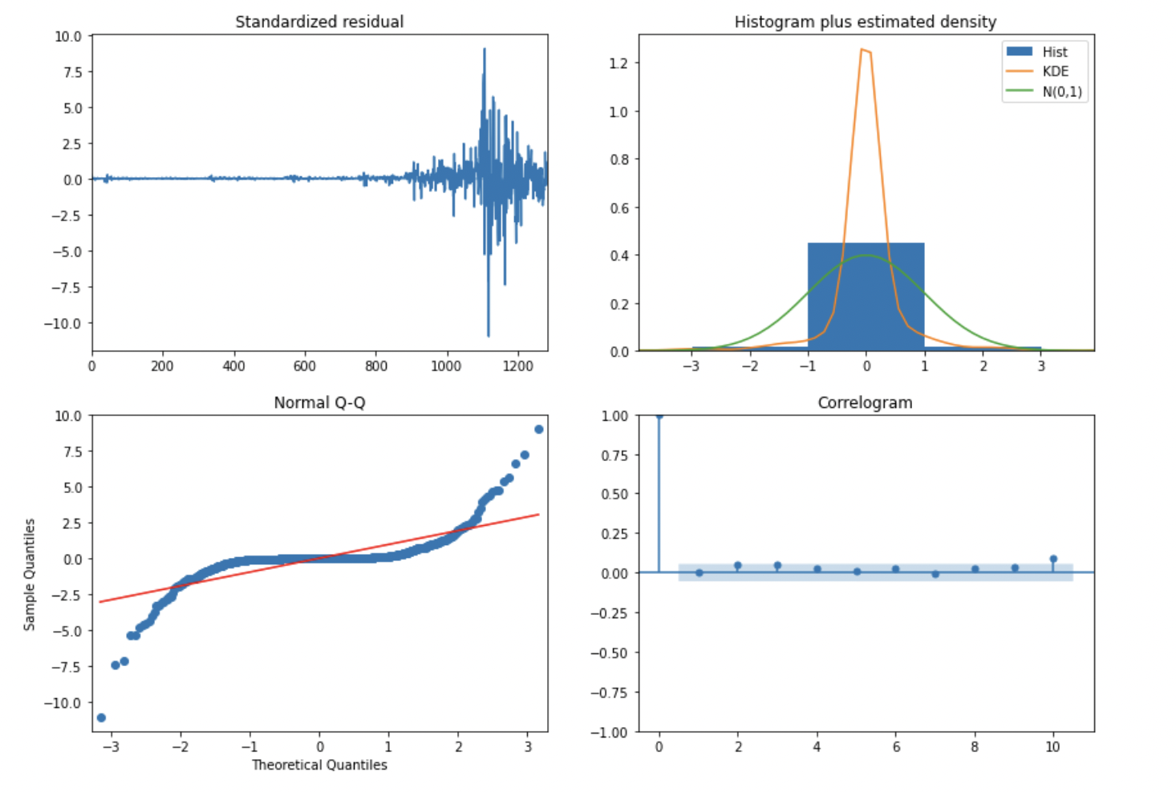

**Validation of model by taking SARIMA test separately**

To validate the results and nonstationary trend, we have performed SARIMA test and the statistics are given below:

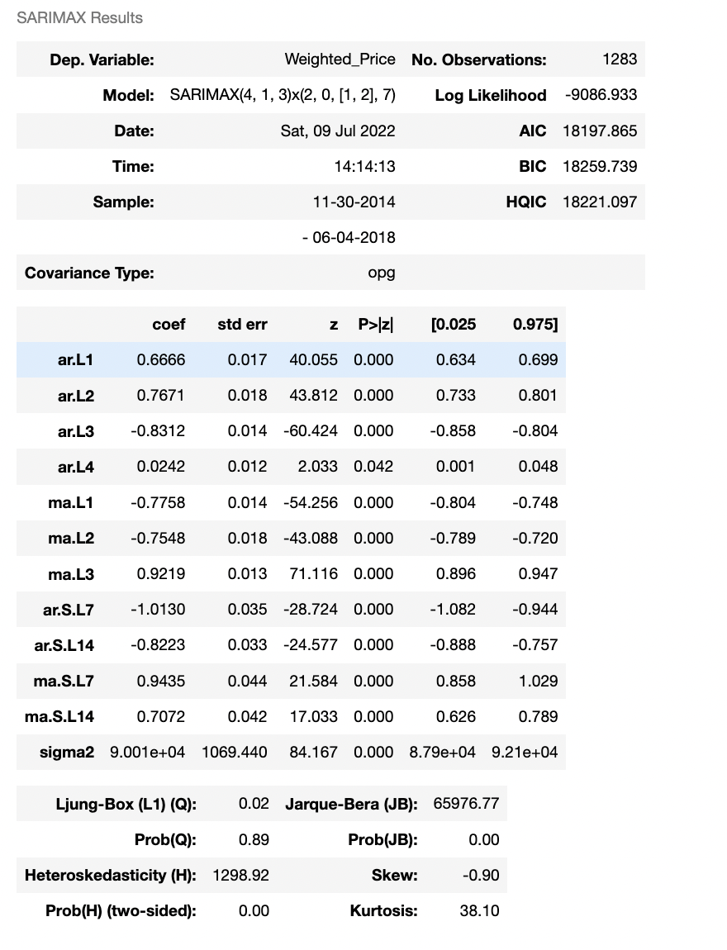

The above table is similar to Auto-ARIMA summary table. Hence, the seasonal test is most suited for this seasonal dataset.

Following are the residuals plots, and these are again confirming that our model is not performing properly.

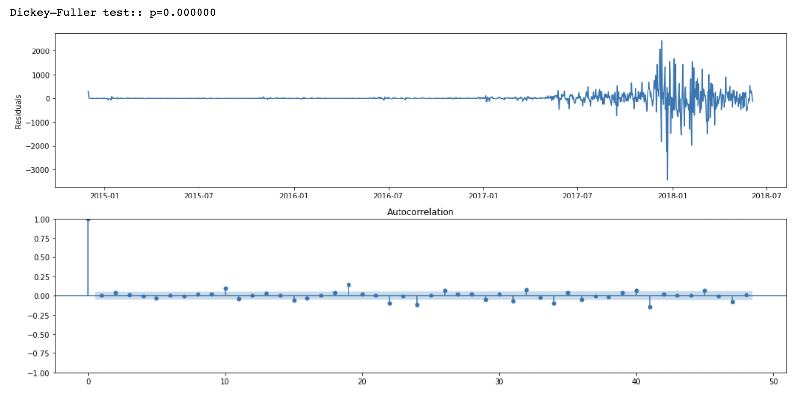

**Prediction Test**

When we use test dataset to predict on train dataset for validation of our model, we have found that the model is not a best fit model. The prediction starts well in the beginning of timestamp but after some time the original weighted price and predicated weighted price has significant difference.

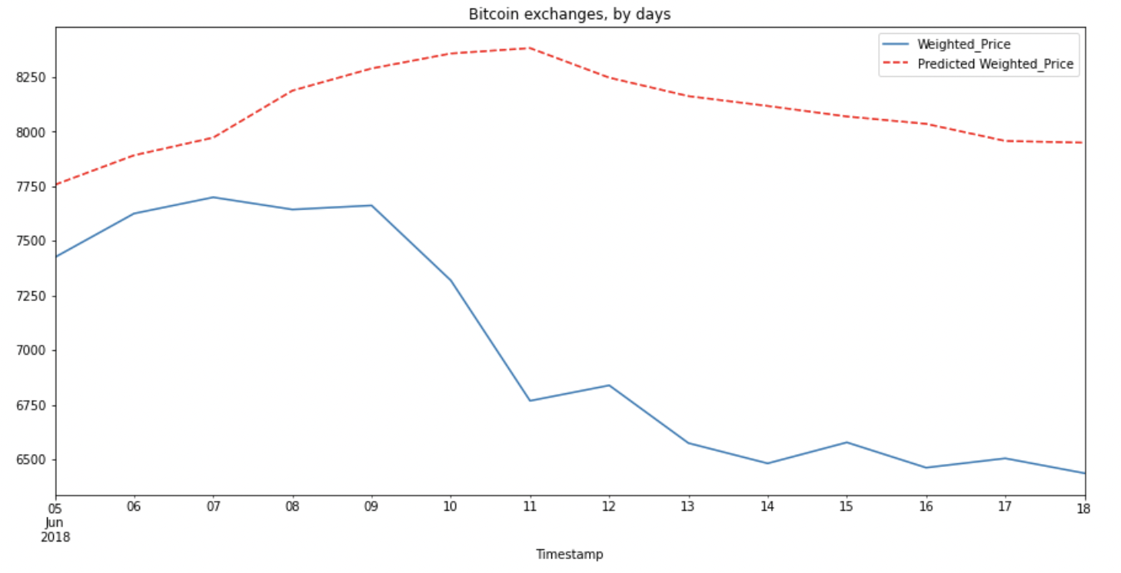

**Prediction Train**

The prediction based on train dataset is **overfitting** our weighted price with predicted weighted price.

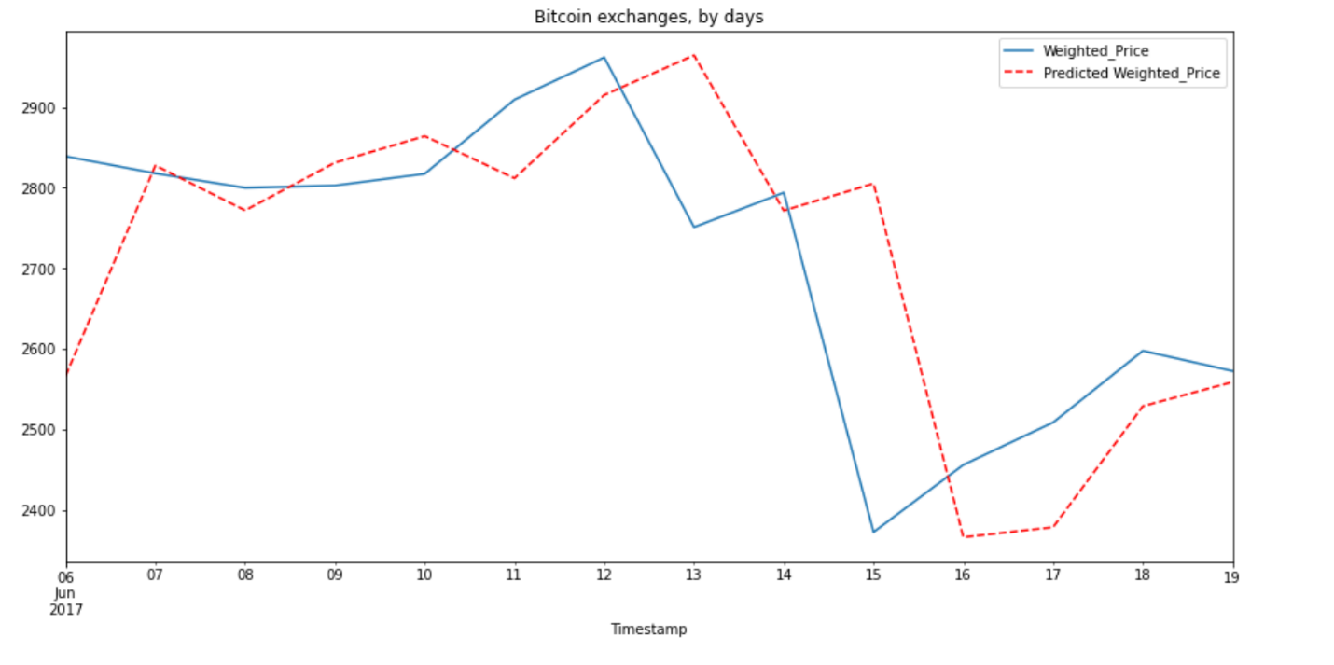

**Evaluation of Prediction**

The evaluation is done by using root mean square error. By observing the values from following picture, the test dataset is predicting weighted price with RMSE values of 1492.19 which is very large and thus we can say that this prediction is overfitting.

Further, the predictions considered from train dataset is giving us RMSE = 289.17 which is comparatively low from above value.

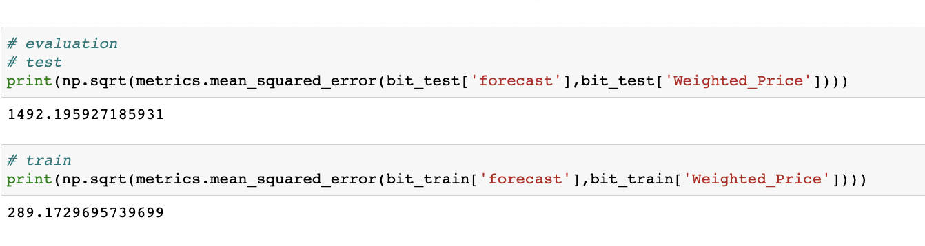

**Summary:**

* We start up understand the bitcoin dataset in-depth going through each variable and its significance.
* Starting with the EDA, we analyzed the datatype and characteristics of each variable.
* We then checked for the missing values in our dataset. As the bitcoin prices were in time steps of minutes, there were a lot of Null- unaccounted price periods. We replaced the missing values of continuous entities like price using “backward fill” based on naïve model assumption. We replaced single event volumes with 0.
* We then plot few line plots to analyze the price/volume vs time association.
* We then split the data where we took 3.5 years for training and rest for evaluation.
* We created two resampled datasets, one with hourly time steps and other with daily time steps.
* We then used Auto-Arima to get the best parameter combinations of order and seasonal order, making the dataset stationary.
* Using this parameter, we designed a SARIMAX model and analyzed its equations and residuals.
* We evaluated our model using RMSE. We found out that our training RMSE was very low compared to testing which states that our base model is overfitting. This analysis helped us to go for more powerful model LSTM.